# Advancing MiR-CLIP as a discovery tool in cell and tissue regeneration

A dissertation submitted to The University of Manchester for the degree of Msc in bioinformatics and systems biology in the Faculty of Faculty of Biology, Medicine, and Health

2024

Student ID 10980069

List of Contents

Advancing MiR-CLIP as a discovery tool in cell and tissue regeneration 1

Abstract 1

Declaration 1

Acknowledgements 2

Intellectual property statement 2

Introduction 3

Keratinocytes and Cell Junction 3

The process of wound healing 3

Pathways in wound healing 4

MiRNA in skin and their targeting 6

Aims 8

Methods 8

Gene expression and pathways 8

Pathways analysis 9

Gene communication network 9

miR-CLIP analysis and discovery of miRNA-29 direct targeting in adhesion 9

Results 10

Regulatory Effects of miRNA-29 Inhibition on Gene Expression and Pathway Enrichment in Fast Adherent Keratinocytes 10

Divergent Pathway Regulation in Keratinocyte Adhesion: Insights from miRNA-29 Inhibition and Reactome Analysis 13

Correlation Analysis of Differentially Expressed Genes (DEGs) Reveals Intricate Networks in Keratinocytes Upon miRNA-29 Inhibition 15

Analysis of miRNA-29 targets in fast adhesion keratinocytes through MiR-CLIP discovered a direct targeting of Claudin 4 adhesion molecule mRNA 17

Summary of the results 17

Discussion 17

References 17

## Abstract

Wound healing is a complex and tightly regulated process. In this process, miRNAs have emerged as key regulators of gene expression by silencing their targets. Specifically, MiRNA-29 family inhibition has been demonstrated to significantly improve wound healing, suggesting a role of miRNA-29 family targets in the skin barrier formation. In this study, we conducted an in-depth analysis on the effect of miRNA-29 family targets on wound healing and cell adhesion. We analyzed expression data of keratinocytes following miRNA-29 inhibition, and targetome miR-CLIP data to unveil the up-regulated genes and how they impact pathways involved in tissue repair and adhesion. Interestingly, an initial analysis showed an up-regulation of inflammatory pathways through the interaction with molecules such as TNF (Tumor Necrosis Factor), NF-kappaB, and cytokines. Nevertheless, further analyses on up-regulated pathways that were uniquely found post-miRNA-29 depletion suggests that its target genes are involved in cell proliferation and tight junction organization. These findings were also proved by the analysis of gene expression patterns among the direct targets via miR-CLIP assay, where 12 target genes that were highly up-regulated were identified, including CLDN4, FERMT2, SEMA7A, and SESN2. These targets have been shown to improve wound healing by regulating key pathways in cell proliferation and cell junction organization. The discovery of the novel targets may help in the design of further research experiments on wound healing, while inhibitors of miRNA-29 family may represent a potential future class of therapeutic drugs to improve the wound healing outcome in healthcare.

## Declaration

I declare that no portion of the work referred to in the dissertation has been submitted in support of an application for another degree or qualification of this or any other university or other institute of learning Intellectual property statement

## Acknowledgements

I am deeply grateful towards my supervisor, Dr. Svitlana Kurinna. She guided and helped me solve the problems that I was facing in this project with incredible calmness and patience. She provided guidance and suggested necessary corrections. Furthermore, she provided me with all the necessary data that her lab has obtained recently.

## Intellectual property statement

1. The author of this dissertation (including any appendices and/or schedules to this dissertation) owns certain copyright or related rights in it (the “Copyright”) and s/he has given The University of Manchester certain rights to use such Copyright, including for administrative purposes.
2. Copies of this dissertation, either in full or in extracts and whether in hard or electronic copy, may be made only in accordance with the Copyright, Designs and Patents Act 1988 (as amended) and regulations issued under it or, where appropriate, in accordance with licensing agreements which the University has entered into. This page must form part of any such copies made.
3. The ownership of certain Copyright, patents, designs, trademarks, and other intellectual property (the “Intellectual Property”) and any reproductions of copyright works in the dissertation, for example graphs and tables (“Reproductions”), which may be described in this dissertation, may not be owned by the author and may be owned by third parties. Such Intellectual Property and Reproductions cannot and must not be made available for use without the prior written permission of the owner(s) of the relevant Intellectual Property and/or Reproductions.
4. Further information on the conditions under which disclosure, publication and commercialisation of this dissertation, the Copyright and any Intellectual Property and/or Reproductions described in it may take place is available in the [University IP Policy](http://documents.manchester.ac.uk/display.aspx?DocID=24420), in any relevant Dissertation restriction declarations deposited in the University Library, and The [University Library’s regulations](https://www.library.manchester.ac.uk/about/regulations/_files/Library-regulations.pdf)

## Introduction

### Keratinocytes and Cell Junction

Wound care imposes a significant burden on global healthcare systems. In the United Kingdom alone (Guest et al., 2020), the expenditure associated with wound care amounts to approximately 5 billion pounds per year, evidencing the need for advanced treatment to reduce the socio-economic burden of impaired wound healing. The process of wound repair in the epidermis, the outer layer of the skin, is made possible by the regulated coordination of diverse tissue and cell types (Gruber et al., 2020). The epidermis is comprised of stratified epithelium mainly composed cells called keratinocytes. Within the epidermis, keratinocytes’ phenotype differs based on their position in the epidermis. For instance, only keratinocytes attached to the basal layer can proliferate (Pastar et al., 2014). However, keratinocytes in the outer layer undergo cornification, eventually reaching senescence, becoming incapable of proliferation (Waikel et al., 2001). The epidermis, which is made of stratified layers of keratinocyte, is formed through the establishment of inter-cellular adhesion between keratinocytes and the extracellular matrix (Hegde et al., 2021). Inter-cellular adhesion is mediated by the presence of diverse types of junctions. These cell junctions, overall, form the skin barrier and provide tissue integrity (Harding et al., 2002). Nevertheless, each cell junction class presents distinct functions based on its structure and position. For instance, desmosomes are adhesive junctions formed by the binding of intermediate filaments and cadherin proteins. Their binding between neighboring cells provides adherence and mechanical resistance in tissues (Green et al., 2007). Hemidesmosome are another type of adhesive junction, whose role is to anchor keratinocytes at the basal lamina of the extracellular matrix. Hemidesmosomes are composed of integrin receptors at the basal surface which bind to extracellular components such as laminin and collagen (Walko et al., 2015) (Hopkinson et al., 2014). Tight junctions, on the other hand, are specialized structures that seal the intercellular space between adjacent cells, regulating the transport of ions and molecules across the epithelial barrier. These junctions are composed of claudins, occludins, and other transmembrane proteins (Furuse et al., 2002). Lastly, gap junctions serve as communication channels between neighboring cells (Laird et al., 2010). In keratinocytes, these diverse cell junctions are responsible for maintaining the structural integrity of the epidermis, while also regulating the complex network of cellular processes essential for skin homeostasis and wound healing (Wilkinson et al., 2020).

### The process of wound healing

Upon injury, skin cells initiate a precisely regulated response. This response consists of a series of spatial-temporally controlled cellular events that are essential for successful wound healing (Yi et al., 2021). The wound-healing response is divided into three main overlapping phases: inflammation, proliferation, and remodeling (Wallace et al., 2024).

Tissue re-epithelialization, a crucial aspect of the proliferative phase, involves the activation, proliferation, and migration of epidermal cells, which are paramount for the rapid re-establishment of the epidermal barrier (Hegde et al., 2021). Tissue re-epithelialization is initiated and regulated by tightly controlled signaling network (Sumigray et al., 2015). Following wound injury, the release of ligands in the injured skin tissue will induce keratinocytes to undergo dynamic changes affecting their growth, differentiation, and substrate attachment (Hedge et al., 2021). When successful, this regulated response induces migration, proliferation, alterations in cytoskeletal content, which enhance adhesion and promote healing (Nardini et al., 2016). However, the mechanism of wound closure is extraordinarily complex and requires the coordination of biological signals in the epidermis, which involves a complex network of pathways (Stojadinovic et al., 2005).

### Pathways in wound healing

Following skin injury, endothelial cells release a plethora of cytokines and growth factors, including transforming growth factor (TGF)-β, interleukin-4 (IL-4), interferon-γ, tumor necrosis factor (TNF), connective tissue growth factor (CTGF), and platelet-derived growth factor (PDGF), and many more, which elicit signaling cascades in epithelial cells (Mercurio et al., 2020). These cascades often involve pathways such as NF-kB (Shen et al., 2023) and PI3K/AKT, which drive changes in gene expression within the cell, thereby promoting the overall proliferation, adhesion, and migration of keratinocytes during the healing process (Li et al., 2016). The molecular signaling networks involved in skin development and regeneration constitute a highly intricate system, with numerous pathways and proteins operating either synergistically or antagonistically (Rodrigues et al., 2019). The process of proliferation commences with the binding of polypeptide ligands, predominantly growth factors, to receptor tyrosine kinases (RTKs). This binding event triggers a cascade of molecular events, sequentially activating molecules such as PI3K (phosphatidylinositol 3 kinase), Rac, and ERK1/2 (Yin et al., 2020). Consequently, specific transcription factors within the nucleus become activated, inducing cell proliferation (Teng et al., 2021). In cell adhesion, activation of receptor tyrosine kinases (RTKs) initiates a cascade pathway that sequentially involves Ras, PI3K, Rac, c-Raf, MEK, ERK1, MP1, and late endosome, promoting cell adhesion (Schiefermeier et al., 2014). While this pathway shares similarities with the signaling cascade observed in cell proliferation, it also exhibits unique factors and regulatory mechanisms tailored specifically for the adhesion process, which have not been fully understood yet (Wilkinson et al., 2020). The skin, being the largest organ in the human body, performs a multitude of functions orchestrated by a diverse array of cell types. These cells collectively engage in intricate interactions that are essential for maintaining skin health and functionality (Yousef et al., 2020). As highlighted earlier, the process governing wound healing has heightened the level of regulatory mechanisms to ensure precise development and successful tissue regeneration (Ruthenborg et al., 2014).

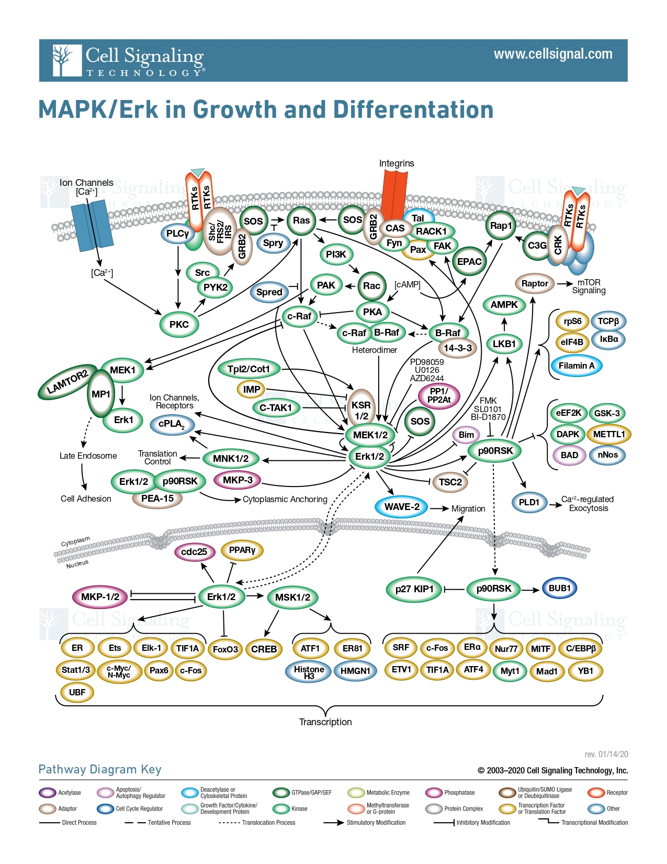

**Figure 1. The intricate nature of cell signal transduction in regulating cell adhesion is exemplified in the diagram.** It visually depicts the proteins responsible for transmitting signals within the cell, which in turn regulate a variety of cellular functions, including cell adhesion. This Illustration was courtesy of Cell Signaling Technology, Inc. ([www.cellsignal.com [cellsignal.com]](https://urldefense.com/v3/__http://www.cellsignal.com__;!!PDiH4ENfjr2_Jw!Ae8CPDicFHidPVy-u9gSTtnFNCa7ibxBBfPGRyj4KHTHKfYDTOCHiCj9oQhqQhhfHMlFQPMGa3fwMg0T5CesJn3eCSfisH5yBK_xhZsSvUaMMb4LdRco$)).

### MiRNA in skin and their targeting

MicroRNAs (miRNAs) play a significant role in gene expression within the skin, as evidenced by the overall increased concentration within the skin tissue (Ghatak et al., 2015). These molecules, typically 18-21 nucleotides in length, possess the remarkable capability to silence messenger RNA (mRNAs), thereby regulating the expression of genes involved in multiple pathways. This regulatory function extends across various biological contexts, ultimately shaping the phenotype in both animals and plants (Horsburgh et al., 2017). Despite constituting merely a small fraction, approximately 1-5%, of the human genome, miRNAs wield significant regulatory influence over roughly one-third of protein-coding genes. These regulatory actions extend to pivotal pathways governing processes such as proliferation, differentiation, and even tumorigenesis (Volovat et al., 2020). The genesis of miRNAs commences within the nucleus, where primary miRNAs (pri-miRNAs), hairpin-shaped double-stranded nucleotides, are transcribed and undergo cleavage by the ribonuclease III enzyme DROSHA, yielding precursor miRNAs (pre-miRNAs). Subsequently, pre-miRNAs are exported to the cytoplasm, where the Dicer protein further processes them into mature miRNAs. The resultant miRNAs are then associated with Argonaute proteins within the miRNA-induced silencing complex (RISC), where only the guide strand persisting for subsequent mRNA targeting and silencing (Gebert et al., 2018). MiRNAs do not function as simple on-off switches. Instead, they regulate gene expression levels through partial complementarity between the seed sequence—a short nucleotide sequence typically found at positions 2 to 8 of the miRNA—and the 3’untranslated region (UTR) of messenger RNA (mRNAs). Upon binding via imperfect sequence match, miRNAs do not trigger mRNA cleavage mediated by the RISC complex. Rather, this partial complementarity leads to mRNA destabilization, followed by decapping and decay (Zhou et al., 2013). Nonetheless, this incomplete match allows a single miRNA to target multiple mRNA molecules, potentially regulating the activity of numerous genes, sometimes reaching up to a thousand targets (Riolo et al., 2020). This results in a complex regulatory mechanism where miRNAs finely adjust gene expression, contributing significantly to the downregulation of protein networks (Yi et al., 2009).

Numerous miRNAs have been identified to exert regulatory effects on the skin. Among them, the miR-29 family, comprising miR-29a, miR-29b-1, miR-29b-2, and miR-29c, has emerged as a key player in skin barrier formation and wound healing (Kurinna et al., 2014) (Kurinna et al., 2021) (Robinson et al., 2024). These miRNAs have been shown to target genes involved in various skin processes, including collagen signaling and endoderm development (Harmanci et al., 2017). Significantly, knockout studies conducted in vivo targeting the miRNA-29 family have resulted in notable enhancements in cell-to-matrix adhesion. This promotion of wound healing occurs through the interaction of miRNA-29 targets, such as laminin y2, and the facilitation of angiogenesis and tissue granulation (Robinson et al., 2024).

Furthermore, in addition to their conventional post-transcriptional regulatory functions, targets of the miRNA-29 family also impact epigenetic modifications, potentially creating a dynamic feedback loop that influences cellular responses. Specifically, members of the miR-29 family have been linked to DNA methylation and histone modifications, and ultimately leading to cellular senescence (Lyu et al., 2018), typical of low-replicative keratinocytes found in the outer layers of the epidermis (Gruber et al., 2020).

MiRNA-29 family targets exert significant regulatory influence on key cellular pathways and processes essential for wound healing. However, the identification of direct targets of miRNA-29 family gene silencing presents a significant challenge due to the presence of multiple targets and the potential for miRNA binding to occur in regions outside the 3'UTR, such as in the open reading frame (ORF), and in 5'UTR of mRNAs, thereby increasing the complexity of target determination (Agarwal et al., 2015). To address this challenge, researchers have developed both biochemical assays and computational methods, which play crucial roles in predicting miRNA targets and elucidating the complexities of miRNA-mRNA interactions (Steinkraus et al., 2016).

Among those techniques, one of the most recent and efficient methods for determining miRNA targets is microRNA crosslinking and immunoprecipitation (miR-CLIP). The miR-CLIP method involves the utilization of a pre-miRNA probe incorporating a specific miRNA sequence coupled with psoralen and biotin groups. Upon mild radiation, this probe is introduced into cells, where it undergoes processing into mature miRNAs capable of binding to their targets via base complementarity. Subsequently, the miR-CLIP-mRNA complex is isolated through immunoprecipitation using an Ago 2 antibody. The sequence-specific bound miRNA sequence targets are then extracted using streptavidin thanks to its affinity with the biotin group attached to the probe. The isolated mRNA is subsequently subjected to deep sequencing, enabling the identification of enriched mRNAs, indicative of miRNA targets. This method facilitates the rapid and precise identification of specific miRNA targets, thereby shedding light on their involvement in intricate biological processes such as wound healing (Wang et al., 2020) (Imig et al., 2014).

The multifaceted process of cell adhesion during wound healing encompasses complex molecular networks, with the miR-29 family emerging as pivotal regulators. Investigating their regulatory influence on keratinocyte adhesion, as well as on pathways such as PI3K/AKT and NF-κB, promises valuable insights into the intricate interplay governing epidermal repair. Given the escalating global healthcare burden associated with wound care, understanding these molecular complexities holds significant potential for developing targeted therapeutic interventions aimed at improving wound healing outcomes.

### Aims

This study's objectives were to investigate the miRNA-29 family's impact on cell adhesion during wound healing. The gene expression profiles of keratinocytes exhibiting rapid surface adhesion, termed "fast adhesion", were analyzed in the presence and absence of a miRNA-29-specific inhibitor. The pathways affected by the differentially expressed genes following inhibition were examined, with focus on cell adhesion. These findings were then integrated with miRNA-29 family targeting miR-CLIP data to identify the direct targets of the miRNA-29 family that influence keratinocyte adhesion during the wound healing process. Furthermore, we utilized miRNA-29 family targets to elucidate the complex interactions occurring in tissue regeneration, identifying proteins and pathways involved in this process.

## Methods

### Gene expression and pathways

The study involved analyzing gene expression data obtained from DESEQ2 results, which were categorized into four distinct types of keratinocytes:

1. Fast adhesion keratinocytes following miRNA-29 family inhibition (fast_abc).
2. Slow adhesion keratinocytes following miRNA-29 family inhibition (slow_abc).
3. Fast adhesion keratinocytes following non-specific inhibition serving as the control (fast_nsa).
4. Slow adhesion keratinocytes following non-specific inhibition serving as the control (slow_nsa)

Differentially expressed genes (DEGs) in the cell samples were selected by filtering using an adjusted p-value below 0.05 and a log2 fold change higher than 0.5. The fold change threshold was set to that amount to capture significant differences in gene expression while reducing the noise in the analysis due to the presence of an excessive number of genes. Following the identification of differentially expressed genes (DEGs), gene enrichment analysis was conducted for each comparison utilizing Enrichr (Chen et al., 2013) and Webgestalt 2019 (Liao et al., 2019). Enriched Gene Ontology terms were then ordered in descending order according to the negative logarithm of the p-value (-Log10(p_value)).

Targetome analysis was performed on the miR-CLIP data. The MiR-CLIP dataset contained the list of mRNAs and their fold change in expression along with the one-hot encoding of the 6mer, 7mer, 8mer sequence used to confirm the presence or not of complementarity between the seed sequence of the miRNA-29 family and 3’UTR of the targeted mRNAs. The genes have been filtered to contain at least one match in the sequence (complementarity is present) and to present a fold change above a certain threshold (2, 4, 10). Gene Ontology terms were then ordered in descending order according to the negative logarithm of the p-value (-Log10(p_value)).

### Pathways analysis

From the gene expression data, mRNAs with expression log2 fold change above 0.5 and adjusted p-value below 0.05 were selected and analyzed using the Reactome pathway enrichment analysis tool in Webgestalt. The top 100 upregulated Reactome pathways with the lowest p-values were selected for each keratinocyte sample, including fast and slow adhesion keratinocytes in the presence of miRNA-29 family inhibitor or in the presence of a non-specific inhibitor (nsa) acting as a control. The identified reactions were then listed and graphed. The first column shows commonly found pathways that were up-regulated, while the second and the third display the up-regulation of cell-specific unique pathways. In each graph, the number of mRNAs among the differentially expressed genes that belong to that “Reactome Pathways” term was listed. Pathways were then ordered in descending order according to the negative logarithm of the p-value (-Log10(p_value)) to improve the visualization of the results.

### Gene communication network

In the final phase, an effort was made to understand the gene interactions among differentially expressed genes (DEGs) by constructing a network graph. In this graph, DEGs were depicted as nodes, while edges connected genes with a correlation in expression greater than 0.6. To ensure a manageable and visually comprehensible graph without compromising meaningful results, the ideal number of DEGs ranged between 100 and 150. However, certain comparisons among cell types yielded a substantially greater number of DEGs. To address this, the fold2 change was increased, and the p-value was reduced. For instance, the number of differentially expressed genes (DEGs) was notably high in two scenarios: comparing fast adhesion with miRNA-29 inhibition to fast adhesion without inhibition and comparing slow adhesion with miRNA-29 inhibition to slow adhesion without inhibition. Therefore, the number of DEGs nodes in the graph was decreased by setting the threshold of log2 Fold Change, and the adjusted p-value to above 0.75 and below 0.01, respectively. For the remaining comparisons, the cutoff values remained consistent with those employed in the gene enrichment analysis and Reactome analysis. Clusters of nodes (DEGs) were identified using the label propagation-based algorithm in iGraph. Subsequently, each cluster was assigned a Gene Ontology (GO) Term based on the most prevalent biological process (BP) GO Term present among the nodes within that cluster (R script is available on GitHub repository https://github.com/davidmandia/Cell-communication-miRNA-data-fast-adhesion-keratinocytes).

### miR-CLIP analysis and discovery of miRNA-29 direct targeting in adhesion

To identify the direct targets of miRNA-29 involved in keratinocyte adhesion, we selected miRNAs that were up regulated in gene expression of fast adhesion keratinocytes and identified in miR-CLIP data. We filtered mRNAs with a fold change above 0.5 (approximately 1.43x fold change) in the fast adhesion keratinocytes group following miRNA-29 family inhibition(fast_abc). These mRNAs were then compared to the list of enriched mRNAs in the miR-CLIP data at different fold change thresholds (2, 4, 10). Gene enrichment analysis was performed using Webgestalt 2019 with the common mRNA lists for each threshold.

## Results

### Regulatory Effects of miRNA-29 Inhibition on Gene Expression and Pathway Enrichment in Fast Adherent Keratinocytes

Differentially expressed genes (DEGs) were utilized for gene enrichment analysis. Particularly, comparisons between fast adherent keratinocytes following miRNA-29 inhibition (fast abc) and fast adherent keratinocytes following non-specific inhibition acting as control ( fast_nsa) were used to investigate the impact of miRNA-29 family targets on fast adhesion. These analyses revealed an involvement of miRNA-29 in the regulation of various cellular components (CC) crucial to adhesion, including bicellular tight Junction, cell membrane, and collagen extracellular matrix (Fig. 2A).

Moreover, Fig. 2A also indicates the involvement of miRNA-29 family targets in transcription regulation by affecting cellular component (CC) in the chromatin structure. Cellular communication components were also up-regulated following miRNA-29 family depletion by affecting the emission of secretory granules. This observation is further supported by pathway enrichment analysis, where genes overexpressed during the inhibition of miRNA-29 family in fast adhesion keratinocytes contribute to the enrichment of pathways such as TNF/NF-κB, Interleukins, and other pathways associated with keratinocyte proliferation (Fig 2B). On the other hand, the gene enrichment analysis of downregulated genes predominantly yielded non-significant results (p_value > 0.05), except for a notable impact on collagen signaling and endoderm development mediated by Collagen 4 and 5 genes.

In the miR-CLIP data analysis, genes exhibiting a fold change above 2 and at least one match in the 3’UTR of mRNAs totaled more than 1000 targets, an unmanageable number of genes. This abundance of genes rendered gene enrichment analysis challenging, as it is recommended to have a more manageable number of genes, ideally between 15 and 500, for effective analysis (https://www.gsea-msigdb.org/). Therefore, the fold change threshold has been increased to reduce the number of target genes. Upon increase of the threshold to 4, an upregulation of processed involved in transcription, apoptosis, and signalling pathways including PI3K/ Akt were up regulated. The miRNA-29 direct targets, which exhibited upregulation in the miRNA-29 targeting miR-CLIP analysis, were found to be associated with several key pathways, including gene expression, MAPK (Mitogen Activated Protein Kinase) signaling, tight junctions' maintenance, and mRNA stability (Fig 2C). Notably, tight junctions were upregulated due to the presence of PARD6B and CLDN4. PARD6B, a gene encoding an adapter protein vital for cell polarity, plays a crucial role in the formation of epithelial cell junctions. (Gomes et al., 2021), whereas CLDN4 codes for claudin, an essential component of tight junctions.

Therefore, the inhibition of miRNA-29 family appears to indirectly affect cytokine interactions and signal transduction pathways, while the direct targets of miRNA-29 include regulator of transcription, mRNA stability, and cellular adhesion.

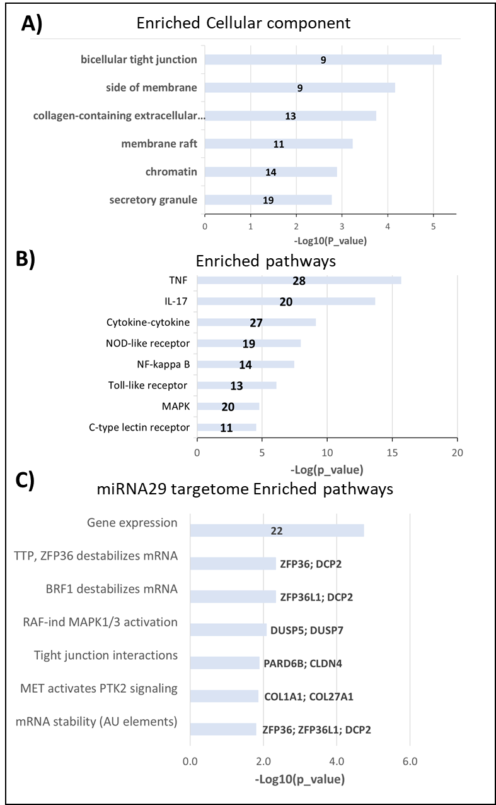

**Figure 2. Inhibition of miRNA-29 resulted in an overall increase in cell signaling, cell proliferation, and cell adhesion due to the upregulation of miRNA-29 family target genes.** Results of the enrichment analysis of upregulated genes in fast adhesion keratinocytes following inhibition of miRNA-29. Gene set enrichment analysis of upregulated genes in fast adhesion keratinocytes following miRNA-29 in the presence of miRNA-29 family inhibitor ( fast_abc) compared to absence of inhibitor (fast_nsa) using Enrichr Cellullar component (A), and pathways using Webgestalt 2019 KEGG (B). Webgestalt 2019 Reactome of the 100 mRNAs with the highest fold change and one match of the miRNA-29 seed sequence in the target mRNA (C). BTG2; ARID3A; SESN2; ZNF92 were responsible for gene expression

### Divergent Pathway Regulation in Keratinocyte Adhesion: Insights from miRNA-29 Inhibition and Reactome Analysis

The impact of upregulated genes in fast adherent keratinocytes when miRNA-29 was inhibited, compared to the Reactome results of the control group revealed a notable divergence in pathways owing to the presence of the miRNA-29 inhibitor. Signaling by Pre-Notch was the only common pathway with a p_value of 0.01. In contrast, “Pathways Reactome” unique to fast adhesion post-miRNA-29 family inhibition keratinocytes exhibited a plethora of unique pathways, encompassing well-established contributors to cell proliferation and signal transduction, notably TNF and NfKappaB, alongside intricate interactions within interleukins and Rhodopsin. Conversely, pathways exclusive to the control group exhibited a proclivity towards keratinocyte differentiation and epigenetic control. Specifically, these pathways implicated chromatin structural alterations, senescence, and the formation of the cornified envelope (Fig 3A). This implies that in the absence of miRNA-29 inhibitors, the regulatory mechanisms governing keratinocyte adhesion and differentiation are primarily dictated by epigenetic factors, and by intricate process of keratinization

The pathway analysis of fast and slow adhesion, mediated by miRNA-29 inhibitor (fast_abc/nsa vs slow_abc/nsa), revealed a considerable number of shared pathways, including MAPK 1/3, interleukins, TNF, and Toll-like Receptor. However, distinct Reactome pathways remained unique to each condition.

Notably, Interleukin 6 signaling emerged as exclusive to fast adhesion, exhibiting the lowest p-value. Furthermore, tight junction interactions, PI3/AKT activation, estrogen dependent gene expression, senescence-like secretory phenotype, and TNF binding are also uniquely up regulated in fast adhesion keratinocytes in the presence of miRNA-29 specific inhibitor (fast_abc/fast nsa). The inhibition of miRNA-29 family results in an augmented tight junction interaction due to the up-regulation of claudins proteins CLDN4, CLDN16, and CLDN7.

On the other hand, WNT and STAT5 pathways were uniquely enriched in slow adhesion (Fig 3B). These findings suggest that miRNA-29 targets are involved in cell adhesion via the up-regulation of claudins, in key cell proliferation pathways, and inflammatory factors such as cytokine.

The last comparison sought to elucidate variances in keratinocyte adhesion differentiation when exposed to the miRNA-29 family inhibitor compared to its absence (fast_abc/slow_abc vs fast_nsa/slow_nsa). As anticipated, the shared “Reactome Pathways” encompassed reactions associated to keratinocyte differentiation, including the formation of the cornified envelope and pre-transcriptional regulation. Intriguingly, reactions unique to fast adhesion were implicated in cytokine and chemokine signaling (Fig 3C), potentially shedding light on the involvement of inflammatory factors activation by miRNA-29 targets specific to fast-adhesion keratinocytes. None of the pathways uniquely up regulated in keratinocyte differentiation in the control set (non-specific inhibitor, nsa) exhibited a significance level below 0.05. Notably, the number of differentially expressed genes in these 2 sets is lower than in other sets since the enriched pathways only differ due the presence of miRNA-family inhibitor.

In summary, the pathways analysis underscores a meticulous regulation of pathways in fast adhesion keratinocytes. The inhibition of the miRNA-29 family has been observed to up-regulate tight junctions by targeting claudin proteins such as CLDN4, CLDN16, and CLDN7. In addition to that, well-established pathways associated with keratinocyte proliferation and inflammatory response in wound healing were upregulated in the presence of miRNA-29 family inhibitor, notably TNF, PI3/AKT pathways, and the secretion of cytokines.

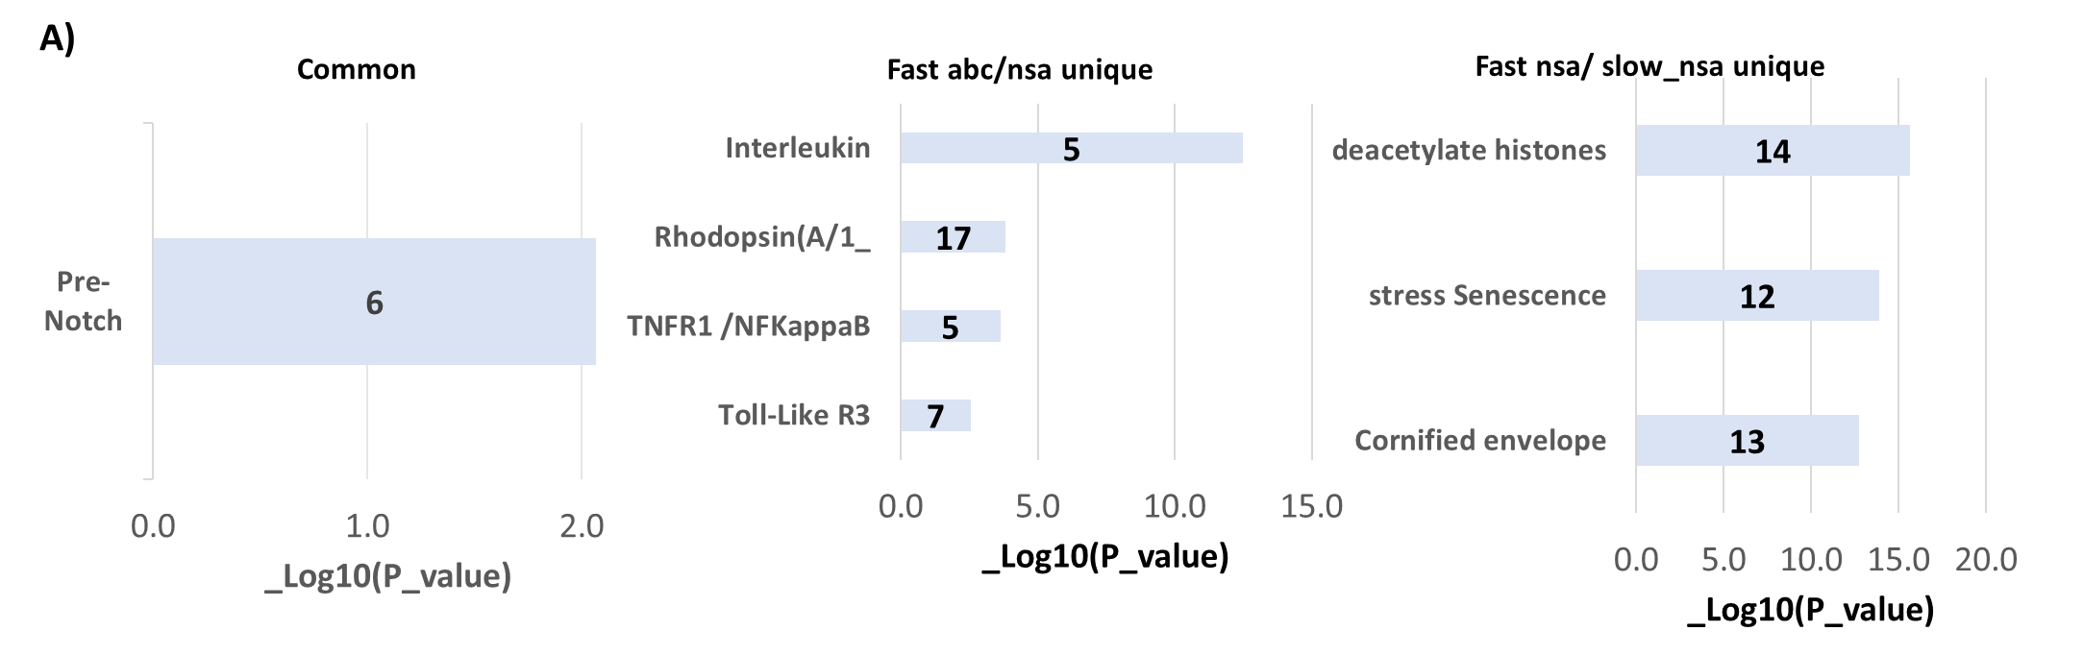

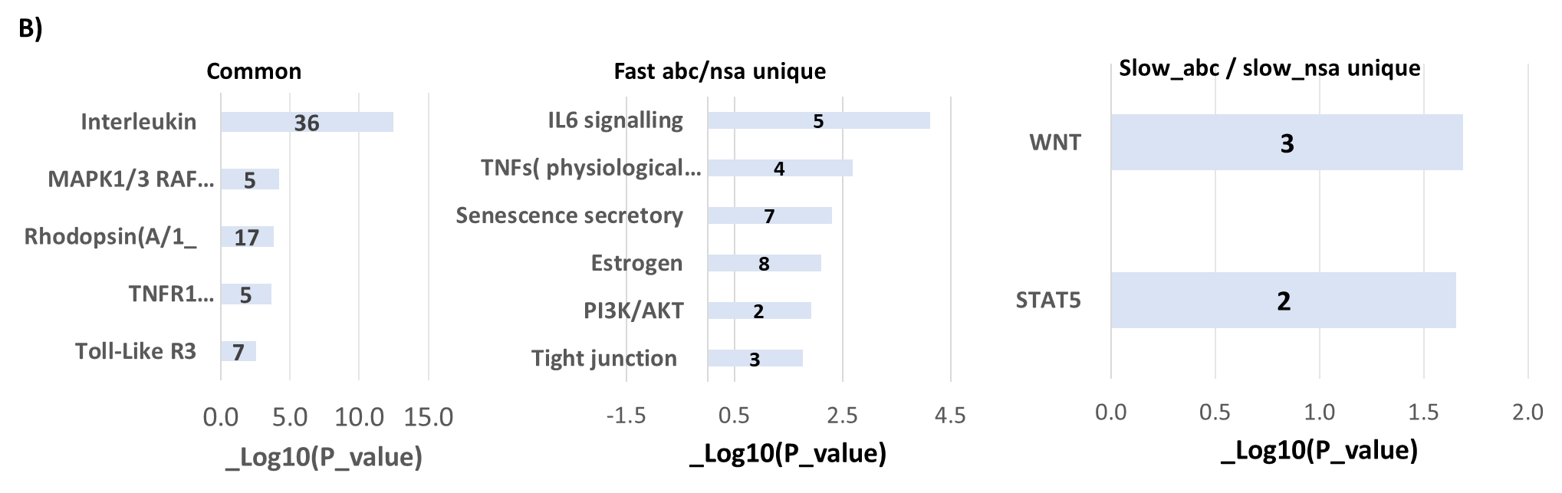

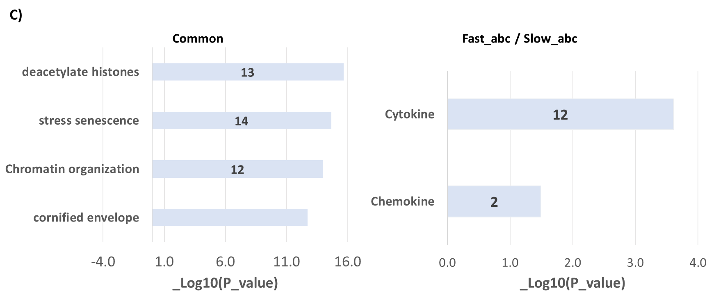

**Figure 3. MiRNA-29 targets up-regulate key pathways affecting adhesion and proliferation.** Reactome analysis of unique and common pathways in keratinocytes depending on miRNA-29 inhibitor presence order by p_value with number of mRNAs inside the bar. Reactome analysis of fast adhesion keratinocytes in the presence of miRNA-29 inhibitor (fast_abc/fast_nsa ) upregulated pathways compared to fast adhesion in the absence of miRNA-29 inhibitor (control)(A) Similarly, analysis on the effect of miRNA-29 inhibitor comparing fast and slow adhesion (fast_abc/nsa and slow_abc/nsa) (B). Finally, the effect of miRNA-29 inhibitor on keratinocytes adhesion differentiation (fast_abc/slow_abc vs fast_nsa/slow_nsa) (C)* abc is the miRNA-29 specific inhibitor, nsa is the non-specific inhibitor (control)

### Correlation Analysis of Differentially Expressed Genes (DEGs) Reveals Intricate Networks in Keratinocytes Upon miRNA-29 Inhibition

The graph containing the network of differentially expressed genes (DEG) that have a correlated expression (corr >0.6) pattern revealed a substantial connectivity between proteolysis, keratinization, and chemokine pathways in the control keratinocytes (Fig 4A). In contrast, the correlation network of DEGs in fast adhesion keratinocytes in the presence of miRNA-29 inhibitor compared to the presence of non-specific inhibitor demonstrated a highly intricate network of gene communication, prominently involving the regulation of RNA polymerase II. Additionally, smaller clusters were involved in protein ubiquitation, and response to viruses (Fig 4B). This indicates that the targets of the miRNA-29 family are involved in up-regulating pathways that directly influence gene expression, potentially amplifying their effect. The correlation network of DEGs following miRNA-29 depletion in fast adhesion compared to slow adhesion keratinocytes (fast_abc vs slow_abc) revealed three separate clusters of genes. These clusters were associated with G-protein signaling pathways, epithelial cell differentiation, and fibroblast growth. Notably, none of these clusters showed connections to each other, suggesting a lack of shared “Gene Ontology Biological Pathways” and correlated expression between the genes of these clusters (Fig 4C).

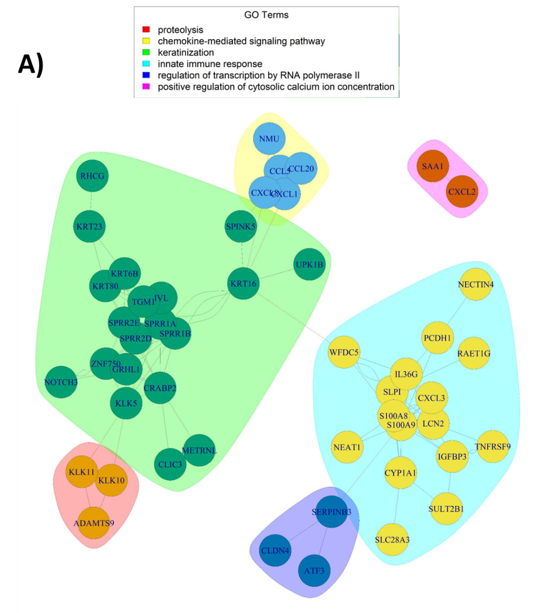

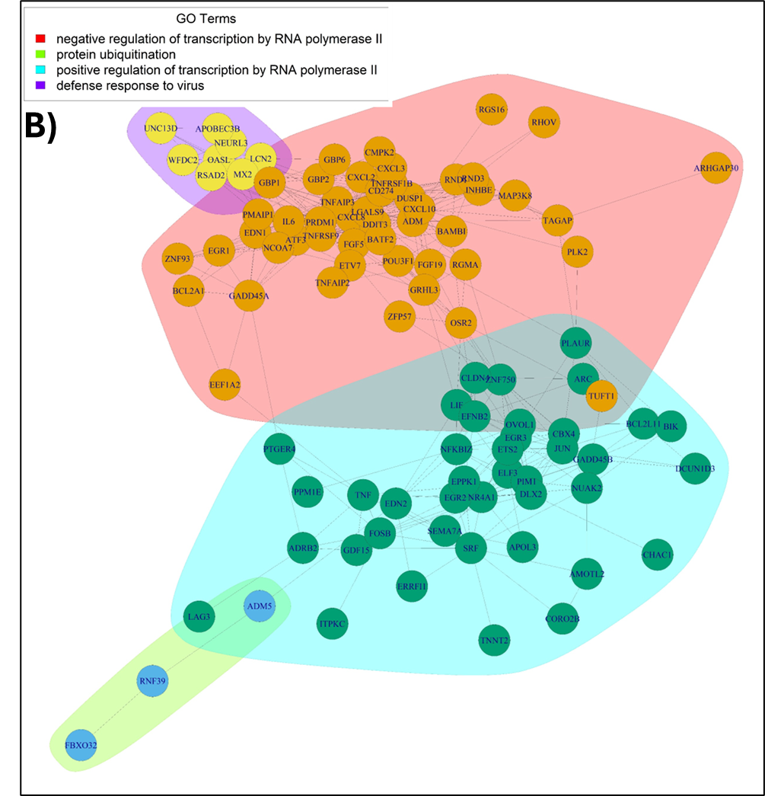

**Figure 4. Gene network analysis of differentially expressed genes.** Gene correlation and biological process terms clustering in upregulated in fast_nsa compared to slow_nsa (control). A) similarly, to up-regulated genes in fast_abc_/fast_nsa (B)*, fast_abc/slow_abc (C). *Figure 4B results from a comparison between cell types that had a higher number of differentially expressed genes, resulting in a higher number of nodes in the graph partially reducing the clarity of the graph

### Analysis of miRNA-29 targets in fast adhesion keratinocytes through MiR-CLIP discovered a direct targeting of Claudin 4 adhesion molecule mRNA

Genes that exhibited upregulation commonly in fast adhesion keratinocytes post miRNA-29 family inhibition and showed strong direct targeting in miR-CLIP analysis, were selected to potentially discover direct targets of miRNA-29 affecting keratinocyte adhesion. Utilizing a miR-CLIP fold change of above 2, the list of common mRNAs contained 66 genes, which were associated with responses to cytokines, signalling cascades, and proliferation. However, further increasing the miR-CLIP fold change to select mRNAs with a miR-CLIP fold change above 4 reduced the number of common mRNAs to 12 (Table 1).

Subsequent analysis of these 12 direct targets revealed a significant up-regulation in cell junction organization (P-value = 0.01), primarily attributed to the direct targeting of CLDN4 and FERMT2. FERMT2, also known as Fermitin family homolog 2 or Kindlin 2, is a regulator of integrin activity involved in cell shape and surface polarity (Qing et al., 2008). Additionally, cell growth was found to be significantly increased (P-value = 2.18E-04) through the targeting of mRNAs such as BCL2L11, PIM1, SEMA7A, SESN2, and STK40 (Table 1). These findings confirm the role of the miRNA-29 family in directly targeting growth and cell adhesion, particularly through the regulation of CLDN4 and FERMT2.

***Table 1. Fold change of the 12 miRNA-29 targets common in miR-CLIP data and gene expression.*** *The table represents the list of the common mRNAs that were upregulated in miRNA-29 inhibitor mediated fast adhesion keratinocytes and miR-CLIP targets. Each row includes gene name, the pathway is involved in (if determined by Webgestalt) fold change in miR-CLIP analysis, and the fold change miRNA-29 family inhibition mediated fast adhesion. *The log2fold change has been converted to fold change to have both fold change on the same scale. Genes involved in cell adhesion have been highlighted.*

| **Gene** | **Pathway** | **MiR-CLIP FC** | **Fast adhesion FC\***  **(post miRNA-29 inhibition)** |
| --- | --- | --- | --- |
| BCL2L11 | Growth | 4.7 | 3.7 |
| CLDN4 | Cell Junction Organization | 4.7 | 3.4 |
| PIM1 | Growth | 4.3 | 2.8 |
| NUAK2 | Glucose Starvation | 5.2 | 2.5 |
| SEMA7A | Growth | 13.4 | 2.3 |
| RNF39 | N/A | 5.9 | 2.3 |
| SP6 | N/A | 4.5 | 2.0 |
| SESN2 | Growth | 9.3 | 2.0 |
| HS3ST1 | N/A | 4.5 | 1.7 |
| DUSP5 | RAF-Independent MAPK1/3 Activation | 7.4 | 1.7 |
| FERMT2 | Cell Junction Organization | 4.2 | 1.7 |

### Summary of the results

In summary, inhibiting the miRNA-29 family resulted in an increase of target genes inducing both cell proliferation and adhesion. Gene expression analysis showed that indirect targets of miRNA-29 influence pathways related to cell proliferation, such as PI3K/MAPK and NF-kappaB. On the other hand, direct targets of miRNA-29 not only affect cell proliferation but also impact cell adhesion, notably through the adhesion molecule claudin 4 (CLDN4) (Fig 5). This dual effect underscores the multifaceted role of miRNA-29 in regulating cellular processes critical for wound healing and tissue regeneration.

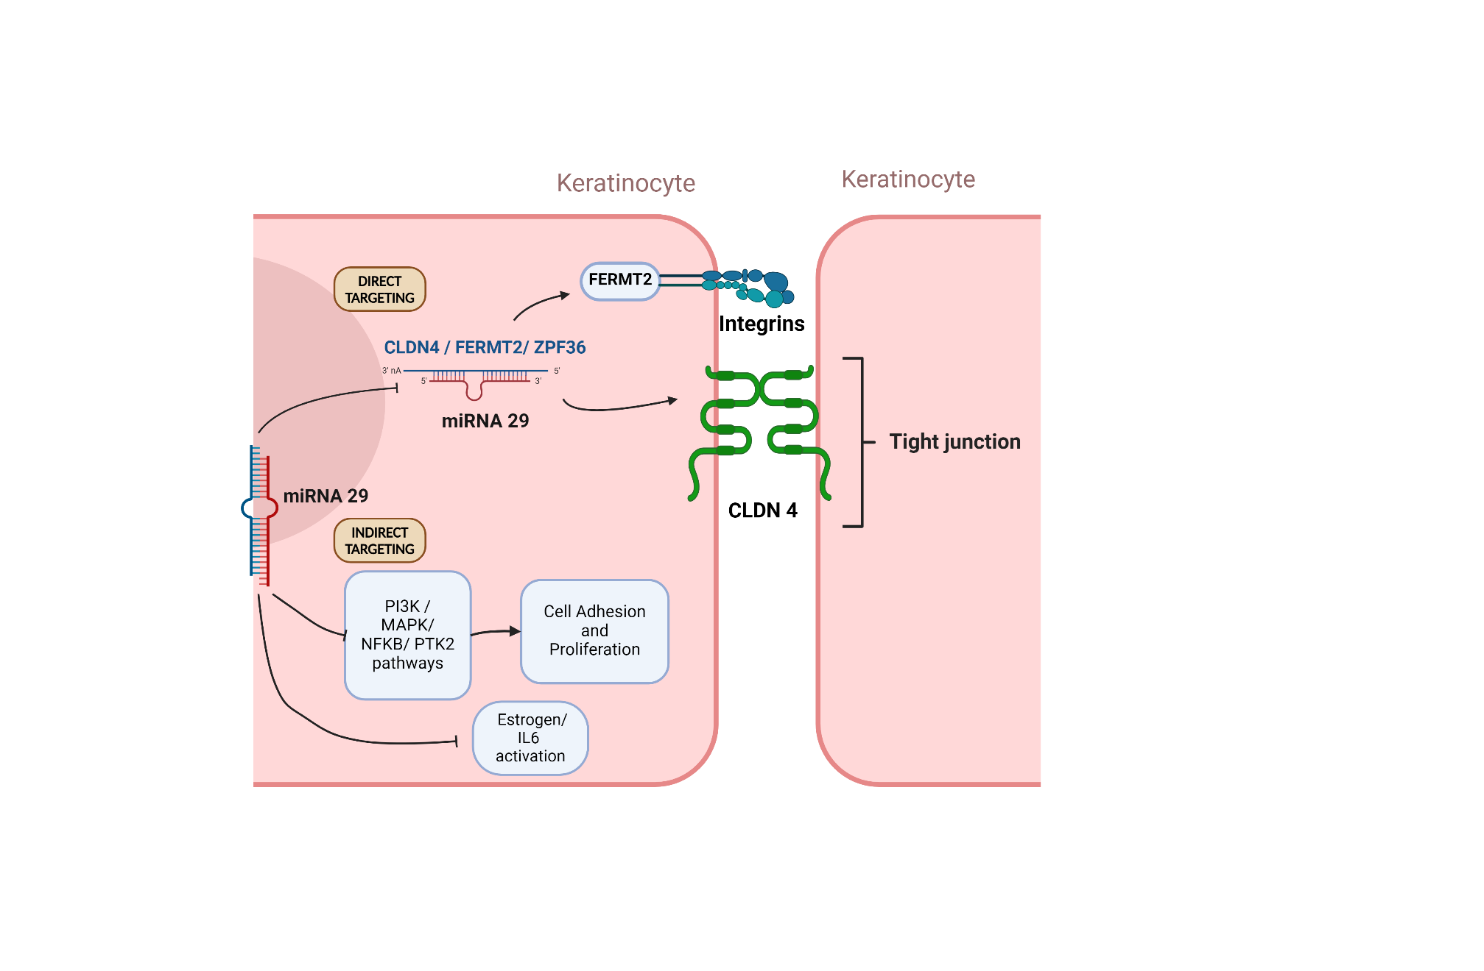

Figure 5. Schematics summary of miRNA-29 targeting in cell adhesion in the epidermis. The figure has been created with BioRender.com

## Discussion

Healthcare expenditure on wound care is notably high, with the treatment of chronic wounds alone accounting for up to 5% of the total healthcare expenditure (Meng et al., 2018). This figure is expected to rise further due to factors such as the aging population and the increasing prevalence of conditions like diabetes (Guest et al., 2015). During the wound healing process, the expression of miRNA-related proteins like Dicer is heightened, indicating the significant involvement of these regulatory molecules in the intricate process of wound repair (Ghatak et al., 2015). The miRNA-29 family, in particular, has been shown to exert a crucial role in tissue epithelialization, with numerous targets identified in the skin that possess both weak and strong binding sites, rendering their regulation and inhibition modulable (Thiagarajan et al., 2022). Depletion of the miRNA-29 family has demonstrated enhanced wound healing outcomes. For instance, upon knockout of miRNA-29, the expression of one of its targets, laminin 2, was elevated at the basal membrane of endothelial cells. This increase in laminin 2 expression contributed to an overall enhancement in neovascularization and re-epithelialization at the wound edge (Robinson et al., 2023). In this experiment, we conducted an in-depth analysis of gene expression patterns and pathways involved following the inhibition of the miRNA-29 family and its impact on keratinocyte adhesion during wound healing. Through pathway analysis, gene network analysis, and miRNA targetome analysis, we uncovered intriguing findings that were compared with existing literature. Pathway analysis in fast adhesion keratinocytes following miRNA-29 depletion initially revealed a significant increase in processes associated with the inflammatory phase of wound healing, including TNF, NF-kappaB, PI3K/Akt signaling, interleukins, and cytokines. Although the direct connection between these pathways and adhesion remains unclear (Yamada et al., 2016), their presence has been demonstrated to be crucial for effective re-epithelialization (Rousselle et al., 2019). Previous studies have identified the miRNA-29 family as a modulator of the PI3K/AKT pathway impacting proliferation rates in keratinocytes (Wei et al., 2017). During wound healing, activated Akt subsequently induces NF-kB translocation to the nucleus, facilitating the transcription of genes associated with cell migration (Yang et al., 2017). Furthermore, AKT activation affects Notch signaling, which has been linked to increased focal adhesion in keratinocytes improving wound healing (Jungtae et al., 2017). Additionally, NF-kappaB translocation into the nucleus increases the transcription of various proteins. One such protein is Intracellular Adhesion Molecule 1 (ICAM-1). ICAM-1 primarily facilitates the binding of leukocytes and does not directly contribute to keratinocyte adhesion (Nagaoga et al., 2020). Nonetheless, its absence has been associated with reduced levels of keratinocyte migration and a diminished transition from the inflammatory to the re-epithelialization phase in keratinocytes (Bui et al., 2020). This may suggest the role of miRNA-29 family targets in modulating the transition from the inflammatory to the proliferative phase. In addition to notorious inflammatory pathways, the “Reactome Pathway” analysis underscores a meticulous regulation of pathways in fast adhesion following miRNA-29 depletion. The inhibition of miRNA-29 targets has already been demonstrated to result in augmented tight junction interactions via upregulation of claudin (Zhou et al., 2015), along with the augmented control of chromatin structure (Lyu et al., 2018), and upregulation of well-established pathways associated with keratinocyte proliferation and the inflammatory response in wound healing (Rousselle et al., 2019). Chromatin structure and epigenetic modifications of histones have been linked to keratinocyte differentiation and adhesion thanks to the modulation caused by expression enhancers. These regulatory elements play a critical role in orchestrating gene expression patterns during keratinocyte differentiation, ultimately influencing adhesion and tissue integrity (Cavazza et al., 2020).

To elucidate cell communication dynamics among the various genes and pathways, gene network analyses were conducted. In such analyses, genes exhibiting correlating expressions were interconnected in network graphs and clustered based on their common biological processes. In the control set comparing fast with slow adhesion in the absence of miRNA-29 inhibitor, the main processes involved in keratinocyte differentiation encompassing processes such as keratinization, chemokines, and immune system response (Juráňová et al., 2017). Following miRNA-29 family inhibition, the majority of clusters were associated with RNA polymerase transcription, consistent with findings from the targetome analysis. Unexpectedly, a set of upregulated genes was commonly involved in ubiquitination. The role of ubiquitination in cell junction regulation remains unclear, adding another layer of complexity to the wound healing cascade. Ubiquitination, as demonstrated by Cai et al. (2017), has been found to affect claudin membrane trafficking, thereby influencing tight junction dynamics and tissue integrity. This post-translational protein modification contributes to the turnover and localization of claudins, ultimately impacting barrier function and wound closure (Cai et al., 2017). However, gene network findings must be taken with caution as correlation does not mean causation, and more studies are necessary to determine the presence of a causal relationship.

Finally, 12 genes were identified as being common among the significantly overexpressed keratinocytes following miRNA-29 depletion and being direct targets of the miRNA-29 family in miR-CLIP analysis. These targets mainly contribute to proliferation and cell junction functions. Among these genes, key players such as CLDN4 (Claudin 4), FERMT2 (Kindlin 2), SEMA7A (Semaphorin 7A, or CD108), and SESN2 (Sestrin2) stand out.

CLDN4, as a crucial component of tight junctions, contributes to tissue integrity and wound closure (Sakamoto et al., 2024; Minowa et al., 2021). Moreover, a claudin protein has previously been identified as a target of miRNA-29, exemplified by the discovery of miRNA-29 family targeting CLDN1 in intestinal tissues (Zhou et al., 2015). Notably, Claudins are a group of proteins in tight junctions that exhibit tissue-specific expressions (Volksdork et al., 2017). FERMT2, expressed in both keratinocytes and fibroblasts, regulates focal adhesion and cell motility, crucial processes for effective wound healing (He et al., 2011; Simpson et al., 2011). While the specific role of blood antigen Semaphorin 7A (SEMA7A) in keratinocytes remains unclear, its ability to promote attachment and spreading in fibroblasts suggests potential indirect effects on wound healing processes (Upadhyay et al., 2021). SESN2, on the other hand, is a stress-responsive protein that induces PI3K/AKT pathway activity, facilitating keratinocyte proliferation and migration, thereby promoting wound healing (Wang et al., 2023). Additionally, targetome analysis of the miRNA-29 family targets using miR-CLIP data unveiled a distinct targeting pattern of gene expression proteins. This discovery adds complexity to our understanding of the overall effect of the miRNA-29 family in wound healing. Moreover, it underscores the imperative for further research to comprehensively understand the implications of inhibiting the miRNA-29 family, especially considering the substantial number of indirect targets affected by the targeting of gene expression.

MiRNA-29 family targets hold promise for the development of therapeutic drugs for wound treatment, but further studies are needed. Research has shown that miRNA-29 family targets play a role in the later stages of wound healing, suggesting the need for more investigations into its effects over time. For instance, during matrix remodeling, miRNA-29b has been found to prevent scar formation by targeting the transforming growth factor beta 1 (TGFβ1) signaling pathway (Guo et al., 2017), highlighting the intricate and timely regulation by miRNAs during wound healing.

Nonetheless, timed regulation could be achieved by the combination of various miRNA inhibitors. These "therapeutic cocktails" made of different miRNA inhibitors may achieve precise timely regulation and potentially yield synergistic effects. For example, miRNA inhibitors targeting claudins (not miRNA-29 family inhibitors) were combined with other miRNA inhibitors related to angiogenesis, resulting in synergistic effects in wound treatment (Roudier et al., 2022). In future research, the exploration of miRNA-29 family inhibitors' efficacy and the nuanced interactions of miRNA-29 targets may present an opportunity to unravel the intricate complexity of the wound healing process with the final intent of developing novel therapeutic treatments specifically designed to address wound care in healthcare.

## References

Agarwal, V., Bell, G. W., Nam, J.-W., & Bartel, D. P. (2015). Predicting effective microRNA target sites in mammalian mRNAs. *ELife*, *4*. <https://doi.org/10.7554/elife.05005>

Bui, T. M., Wiesolek, H. L., & Sumagin, R. (2020). ICAM‐1: A master regulator of cellular responses in inflammation, injury resolution, and tumorigenesis. *Journal of Leukocyte Biology*, *108*(3), 787–799. <https://doi.org/10.1002/jlb.2mr0220-549r>

Cai, J., Culley, M. K., Zhao, Y., & Zhao, J. (2017). The role of ubiquitination and deubiquitination in the regulation of cell junctions. *Protein & Cell*, *9*(9), 754–769. <https://doi.org/10.1007/s13238-017-0486-3>

Cavazza, A., Miccio, A., Romano, O., Petiti, L., Malagoli Tagliazucchi, G., Peano, C., Severgnini, M., Rizzi, E., De Bellis, G., Bicciato, S., & Mavilio, F. (2016). Dynamic Transcriptional and Epigenetic Regulation of Human Epidermal Keratinocyte Differentiation. *Stem Cell Reports*. <https://doi.org/2213-6711>

Chen, E. Y., Tan, C. M., Kou, Y., Duan, Q., Wang, Z., Meirelles, G., Clark, N. R., & Ma’ayan, A. (2013). Enrichr: interactive and collaborative HTML5 gene list enrichment analysis tool. *BMC Bioinformatics*, *14*(1), 128. <https://doi.org/10.1186/1471-2105-14-128>

Furuse, M., Hata, M., Furuse, K., Yoshida, Y., Haratake, A., Sugitani, Y., Noda, T., Kubo, A., & Tsukita, S. (2002). Claudin-based tight junctions are crucial for the mammalian epidermal barrier. *The Journal of Cell Biology*, *156*(6), 1099–1111. <https://doi.org/10.1083/jcb.200110122>

Gebert, L. F. R., & MacRae, I. J. (2018). Regulation of microRNA function in animals. *Nature Reviews Molecular Cell Biology*, *20*(1), 21–37. <https://doi.org/10.1038/s41580-018-0045-7>

Ghatak, S., Chan, Y. C., Khanna, S., Banerjee, J., Weist, J., Roy, S., & Sen, C. K. (2015). Barrier Function of the Repaired Skin Is Disrupted Following Arrest of Dicer in Keratinocytes. *Molecular Therapy*, *23*(7), 1201–1210. <https://doi.org/10.1038/mt.2015.65>

Gomes, M., & Iden, S. (2021). Orchestration of tissue‐scale mechanics and fate decisions by polarity signalling. *The EMBO Journal*, *40*(12). <https://doi.org/10.15252/embj.2020106787>

Green, K. J., & Simpson, C. L. (2007). Desmosomes: New Perspectives on a Classic. *Journal of Investigative Dermatology*, *127*(11), 2499–2515. <https://doi.org/10.1038/sj.jid.5701015>

Gruber, F., Kremslehner, C., Eckhart, L., & Tschachler, E. (2020). Cell aging and cellular senescence in skin aging — Recent advances in fibroblast and keratinocyte biology. *Experimental Gerontology*, *130*, 110780. <https://doi.org/10.1016/j.exger.2019.110780>

Guest, J. F., Ayoub, N., McIlwraith, T., Uchegbu, I., Gerrish, A., Weidlich, D., Vowden, K., & Vowden, P. (2015). Health economic burden that wounds impose on the National Health Service in the UK. *BMJ Open*, *5*(12), e009283. <https://doi.org/10.1136/bmjopen-2015-009283>

Guest, J. F., Fuller, G. W., & Vowden, P. (2020). Cohort Study Evaluating the Burden of Wounds to the UK’s National Health Service in 2017/2018: Update from 2012/2013. *BMJ Open*, *10*(12), e045253. <https://doi.org/10.1136/bmjopen-2020-045253>

Guo, J., Lin, Q., Shao, Y., Rong, L., & Zhang, D. (2017). miR-29b promotes skin wound healing and reduces excessive scar formation by inhibition of the TGF-β1/Smad/CTGF signaling pathway. *Canadian Journal of Physiology and Pharmacology*, *95*(4), 437–442. <https://doi.org/10.1139/cjpp-2016-0248>

Harding, K. G., Morris, H. L., & Patel, G. K. (2002). Healing chronic wounds. *BMJ : British Medical Journal*, *324*(7330), 160–163. <https://www.ncbi.nlm.nih.gov/pmc/articles/PMC1122073/>

He, Y., Esser, P., Heinemann, A., Bruckner-Tuderman, L., & Has, C. (2011). Kindlin-1 and -2 Have Overlapping Functions in Epithelial Cells. *The American Journal of Pathology*, *178*(3), 975–982. <https://doi.org/10.1016/j.ajpath.2010.11.053>

Hegde, A., Ananthan, A. S., Kashyap, C., & Ghosh, S. (2021). Wound Healing by Keratinocytes: A Cytoskeletal Perspective. *Journal of the Indian Institute of Science*, *101*(1), 73–80. <https://doi.org/10.1007/s41745-020-00219-9>

Hopkinson, S. B., Hamill, K. J., Wu, Y., Eisenberg, J. L., Hiroyasu, S., & Jones, J. C. R. (2014). Focal Contact and Hemidesmosomal Proteins in Keratinocyte Migration and Wound Repair. *Advances in Wound Care*, *3*(3), 247–263. <https://doi.org/10.1089/wound.2013.0489>

Imig, J., Brunschweiger, A., Brümmer, A., Guennewig, B., Mittal, N., Kishore, S., Tsikrika, P., Gerber, A. P., Zavolan, M., & Hall, J. (2014). miR-CLIP capture of a miRNA targetome uncovers a lincRNA H19–miR-106a interaction. *Nature Chemical Biology*, *11*(2), 107–114. <https://doi.org/10.1038/nchembio.1713>

Jungtae , N., Shin, J. Y., Jeong, H., Lee, J. Y., Kim, B. J., Kim, W. S., & Yune, T. Y. (2017). JMJD3 and NF-κB-dependent activation of Notch1 gene is required for keratinocyte migration during skin wound healing. *Scientific Reports*, *7*(1). <https://doi.org/10.1038/s41598-017-06750-7>

Juráňová, J., Franková, J., & Ulrichová, J. (2017). The role of keratinocytes in inflammation. *Journal of Applied Biomedicine*, *15*(3), 169–179. <https://doi.org/10.1016/j.jab.2017.05.003>

Kurinna, S., Schäfer, M., Ostano, P., Karouzakis, E., Chiorino, G., Bloch, W., Bachmann, A., Gay, S., Garrod, D., Lefort, K., Dotto, G.-P., Beer, H.-D., & Werner, S. (2014). A novel Nrf2-miR-29-desmocollin-2 axis regulates desmosome function in keratinocytes. *Nature Communications*, *5*(1). <https://doi.org/10.1038/ncomms6099>

Kurinna, S., Seltmann, K., Bachmann, A. L., Schwendimann, A., Thiagarajan, L., Hennig, P., Beer, H., Maria Rosaria Mollo, Missero, C., & Werner, S. (2021). Interaction of the NRF2 and p63 transcription factors promotes keratinocyte proliferation in the epidermis. *Nucleic Acids Research*, *49*(7), 3748–3763. <https://doi.org/10.1093/nar/gkab167>

Laird, D. W. (2010). The gap junction proteome and its relationship to disease. *Trends in Cell Biology*, *20*(2), 92–101. <https://doi.org/10.1016/j.tcb.2009.11.001>

Li, R., Wang, J., Wang, X., Zhou, J., Wang, M., Ma, H., & Xiao, S. (2016). Increased βTrCP are associated with imiquimod-induced psoriasis-like skin inflammation in mice via NF-κB signaling pathway. *Gene*, *592*(1), 164–171. <https://doi.org/10.1016/j.gene.2016.07.066>

Liao, Y., Wang, J., Jaehnig, E. J., Shi, Z., & Zhang, B. (2019). WebGestalt 2019: gene set analysis toolkit with revamped UIs and APIs. *Nucleic Acids Research*, *47*(W1), W199–W205. <https://doi.org/10.1093/nar/gkz401>

Lyu, G., Guan, Y., Zhang, C., Zong, L., Sun, L., Huang, X., Huang, L., Zhang, L., Tian, X.-L., Zhou, Z., & Tao, W. (2018). TGF-β signaling alters H4K20me3 status via miR-29 and contributes to cellular senescence and cardiac aging. *Nature Communications*, *9*(1). <https://doi.org/10.1038/s41467-018-04994-z>

Meng, Z., Zhou, D., Gao, Y., Zeng, M., & Wang, W. (2018). miRNA delivery for skin wound healing. *Advanced Drug Delivery Reviews*, *129*, 308–318. <https://doi.org/10.1016/j.addr.2017.12.011>

Mercurio, L., Failla, C. M., Capriotti, L., Scarponi, C., Facchiano, F., Morelli, M., Rossi, S., Gianluca Pagnanelli, Albanesi, C., Cavani, A., & Madonna, S. (2020). Interleukin (IL)-17/IL-36 axis participates to the crosstalk between endothelial cells and keratinocytes during inflammatory skin responses. *PLOS ONE*, *15*(4), e0222969–e0222969. <https://doi.org/10.1371/journal.pone.0222969>

Minowa, E., Kurashige, Y., Syed Taufiqul Islam, Yoshida, K., Sakakibara, S., Okada, Y., Fujita, Y., Dembereldorj Bolortsetseg, Murai, Y., & Masato Saitoh. (2021). Increased integrity of cell–cell junctions accompanied by increased expression of claudin 4 in keratinocytes stimulated with vitamin D3. *Medical Molecular Morphology*, *54*(4), 346–355. <https://doi.org/10.1007/s00795-021-00299-1>

Nagaoka, T., Kaburagi, Y., Hamaguchi, Y., Hasegawa, M., Takehara, K., Steeber, D. A., Tedder, T. F., & Sato, S. (2000). Delayed Wound Healing in the Absence of Intercellular Adhesion Molecule-1 or L-Selectin Expression. *American Journal of Pathology*, *157*(1), 237–247. <https://doi.org/10.1016/s0002-9440(10)64534-8>

Nardini, J. T., Chapnick, D. A., Liu, X., & Bortz, D. M. (2016). Modeling keratinocyte wound healing dynamics: Cell–cell adhesion promotes sustained collective migration. *Journal of Theoretical Biology*, *400*, 103–117. <https://doi.org/10.1016/j.jtbi.2016.04.015>

Qing, Y., Qin, J., Wu, C., & Plow, E. F. (2008). Kindlin-2 (Mig-2): a co-activator of β3 integrins. *Journal of Cell Biology*, *181*(3), 439–446. <https://doi.org/10.1083/jcb.200710196>

Riolo, G., Cantara, S., Marzocchi, C., & Ricci, C. (2020). miRNA Targets: From Prediction Tools to Experimental Validation. *Methods and Protocols*, *4*(1), 1. <https://doi.org/10.3390/mps4010001>

Robinson, C. J., Thiagarajan, L., Maynard, R., Maneesha Aruketty, Herrera, J., Dingle, L., Reid, A., Wong, J., Cao, H., Dooley, J., Liston, A., Müllhaupt, D., Hiebert, P., Hiebert, H., & Svitlana Kurinna. (2024). Release of miR-29 Target Laminin C2 Improves Skin Repair. *The American Journal of Pathology*, *194*(2), 195–208. <https://doi.org/10.1016/j.ajpath.2023.11.002>

Rodrigues, M., Kosaric, N., Bonham, C. A., & Gurtner, G. C. (2019). Wound Healing: A Cellular Perspective. *Physiological Reviews*, *99*(1), 665–706. <https://doi.org/10.1152/physrev.00067.2017>

Roudier, E., Lemieux, P., & Lam, B. (2022). Treating the diabetic wound through miR inhibitor cocktails: A question of timing? *Molecular Therapy - Nucleic Acids*, *30*, 112–114. <https://doi.org/10.1016/j.omtn.2022.09.014>

Rousselle, P., Braye, F., & Dayan, G. (2019). Re-epithelialization of adult skin wounds: Cellular mechanisms and therapeutic strategies. *Advanced Drug Delivery Reviews*, *146*, 344–365. <https://doi.org/10.1016/j.addr.2018.06.019>

Ruthenborg, R. J., Ban, J.-J., Wazir, A., Takeda, N., & Kim, J. (2014). Regulation of Wound Healing and Fibrosis by Hypoxia and Hypoxia-Inducible Factor-1. *Molecules and Cells*, *37*(9), 637–643. <https://doi.org/10.14348/molcells.2014.0150>

Sakamoto, H., Nishikawa, M., & Yamada, S. (2024). Development of tight junction-strengthening compounds using a high-throughput screening system to evaluate cell surface-localized claudin-1 in keratinocytes. *Scientific Reports*, *14*(1), 3312. <https://doi.org/10.1038/s41598-024-53649-1>

Schiefermeier, N., Scheffler, J. M., Mariana, Taras Stasyk, Yordanov, T. E., Ebner, H., Offterdinger, M., Munck, S., Hess, M., Wickström, S. A., Lange, A., Wunderlich, W., Reinhard Fässler, Teis, D., & Huber, L. A. (2014). The late endosomal p14–MP1 (LAMTOR2/3) complex regulates focal adhesion dynamics during cell migration. *Journal of Cell Biology*, *205*(4), 525–540. <https://doi.org/10.1083/jcb.201310043>

Shen, Y., Anne, Yellon, R. L., & Cook, M. C. (2023). Skin manifestations of inborn errors of NF-κB. *Frontiers in Pediatrics*, *10*. <https://doi.org/10.3389/fped.2022.1098426>

Simpson, C. L., Patel, D. M., & Green, K. J. (2011). Deconstructing the skin: cytoarchitectural determinants of epidermal morphogenesis. *Nature Reviews Molecular Cell Biology*, *12*(9), 565–580. <https://doi.org/10.1038/nrm3175>

Stojadinovic, O., Brem, H., Vouthounis, C., Lee, B., Fallon, J., Stallcup, M., Merchant, A., Galiano, R. D., & Tomic-Canic, M. (2005). Molecular Pathogenesis of Chronic Wounds. *The American Journal of Pathology*, *167*(1), 59–69. <https://doi.org/10.1016/s0002-9440(10)62953-7>

Sumigray, K. D., & Lechler, T. (2015). Cell Adhesion in Epidermal Development and Barrier Formation. *Current Topics in Developmental Biology*, *112*, 383–414. <https://doi.org/10.1016/bs.ctdb.2014.11.027>

Teng, Y., Fan, Y., Ma, J., Lu, W., Liu, N., Chen, Y., Pan, W., & Tao, X. (2021). The PI3K/Akt Pathway: Emerging Roles in Skin Homeostasis and a Group of Non-Malignant Skin Disorders. *Cells*, *10*(5), 1219. <https://doi.org/10.3390/cells10051219>

Thiagarajan, L., Zhang, J., Griffiths-Jones, S., & Svitlana Kurinna. (2022). miR targetome of primary human keratinocytes reveals a function for non-conserved binding sites. *BioRxiv (Cold Spring Harbor Laboratory)*. <https://doi.org/10.1101/2022.07.04.498673>

Upadhyay, P. R., Ho, T., & Abdel‐Malek, Z. A. (2021). Participation of keratinocyte‐ and fibroblast‐derived factors in melanocyte homeostasis, the response to UV, and pigmentary disorders. *Pigment Cell & Melanoma Research*, *34*(4), 762–776. <https://doi.org/10.1111/pcmr.12985>

Volksdorf, T., Heilmann, J., Eming, S. A., Schawjinski, K., Zorn-Kruppa, M., Ueck, C., Vidal-y-Sy, S., Windhorst, S., Manfred Jücker, Moll, I., & Brandner, J. M. (2017). *Tight Junction Proteins Claudin-1 and Occludin Are Important for Cutaneous Wound Healing*. *187*(6), 1301–1312. <https://doi.org/10.1016/j.ajpath.2017.02.006>

Volovat, S. R., Volovat, C., Hordila, I., Hordila, D.-A., Mirestean, C. C., Miron, O. T., Lungulescu, C., Scripcariu, D. V., Stolniceanu, C. R., Konsoulova-Kirova, A. A., Grigorescu, C., Stefanescu, C., Volovat, C. C., & Augustin, I. (2020). MiRNA and LncRNA as Potential Biomarkers in Triple-Negative Breast Cancer: A Review. *Frontiers in Oncology*, *10*. <https://doi.org/10.3389/fonc.2020.526850>

Waikel, R. L., Kawachi, Y., Waikel, P. A., Wang, X.-J., & Roop, D. R. (2001). Deregulated expression of c-Myc depletes epidermal stem cells. *Nature Genetics*, *28*(2), 165–168. <https://doi.org/10.1038/88889>

Walko, G., Castañón, M. J., & Wiche, G. (2015). Molecular architecture and function of the hemidesmosome. *Cell and Tissue Research*, *360*(2), 363–378. <https://doi.org/10.1007/s00441-014-2061-z>

Wallace, H. A., Basehore, B. M., & Zito, P. M. (2024). *Wound Healing Phases*. PubMed; StatPearls Publishing. [https://www.ncbi.nlm.nih.gov/books/NBK470443/#:~:text=By%](https://www.ncbi.nlm.nih.gov/books/NBK470443/#:~:text=By%20days%205%20through%207%2C%20the%20fibroblasts%20have)20days%205%20through%207%2C%20the%20fibroblasts%20have

Wang, K., Shen, K., Han, F., Bai, X., Fang, Z., Jia, Y., Zhang, J., Li, Y., Cai, W., Wang, X., Luo, L., Guo, K., Wang, H., Yang, X., Wang, H., & Hu, D. (2023). Activation of Sestrin2 accelerates deep second-degree burn wound healing through PI3K/AKT pathway. *Archives of Biochemistry and Biophysics*, *743*, 109645. <https://doi.org/10.1016/j.abb.2023.109645>

Wang, Y., Soneson, C., Malinowska, A. L., Laski, A., Ghosh, S., Kanitz, A., Gebert, L. F. R., Robinson, M. D., & Hall, J. (2020). MiR-CLIP reveals *iso*-miR selective regulation in the miR-124 targetome. *Nucleic Acids Research*, *49*(1), 25–37. <https://doi.org/10.1093/nar/gkaa1117>

Wei, W., He, H-B., Zhang, W-Y., Zhang, H-X., Bai, J-B., Liu, H-Z., Cao, J-H., Chang, K-C., Li, X-Y., & Zhao, S-H. (2013). miR-29 targets Akt3 to reduce proliferation and facilitate differentiation of myoblasts in skeletal muscle development. *Cell Death & Disease*, *4*(6), e668–e668. <https://doi.org/10.1038/cddis.2013.184>

Wilkinson, H. N., & Hardman, M. J. (2020). Wound healing: Cellular mechanisms and pathological outcomes. *Open Biology*, *10*(9). <https://doi.org/10.1098/rsob.200223>

Yamada, T., Tsuda, M., Wagatsuma, T., Fujioka, Y., Fujioka, M., Satoh, A. O., Horiuchi, K., Nishide, S., Nanbo, A., Totsuka, Y., Haga, H., Tanaka, S., Shindoh, M., & Ohba, Y. (2016). Receptor activator of NF-κB ligand induces cell adhesion and integrin α2 expression via NF-κB in head and neck cancers. *Scientific Reports*, *6*(1), 23545. <https://doi.org/10.1038/srep23545>

Yang, H.-L., Tsai, Y.-C., Mallikarjuna Korivi, Chang, C., & You-Cheng Hseu. (2017). Lucidone Promotes the Cutaneous Wound Healing Process via Activation of the PI 3 K/AKT, Wnt/β-catenin and NF-κB Signaling Pathways. *Biochimica et Biophysica Acta. Molecular Cell Research*, *1864*(1), 151–168. <https://doi.org/10.1016/j.bbamcr.2016.10.021>

Yi, R., & Fuchs, E. (2009). MicroRNA-mediated control in the skin. *Cell Death & Differentiation*, *17*(2), 229–235. <https://doi.org/10.1038/cdd.2009.92>

Yin, S.-L., Qin, Z.-L., & Yang, X. (2020). Role of periostin in skin wound healing and pathologic scar formation. *Chinese Medical Journal*, *133*(18), 2236–2238. <https://doi.org/10.1097/cm9.0000000000000949>

Yousef, H., Alhajj, M., & Sharma, S. (2020, November 14). *Anatomy, Skin (Integument), Epidermis*. PubMed; StatPearls Publishing. <https://www.ncbi.nlm.nih.gov/books/NBK470464/>

Zhou, P., Xu, W., Peng, X., Luo, Z., Xing, Q., Chen, X., Hou, C., Liang, W., Zhou, J., Wu, X., Zhou Songyang, & Jiang, S. (2013). Large-Scale Screens of miRNA-mRNA Interactions Unveiled That the 3′UTR of a Gene Is Targeted by Multiple miRNAs. *PLOS ONE*, *8*(7), e68204–e68204. <https://doi.org/10.1371/journal.pone.0068204>

Zhou, Q., Costinean, S., Croce, C. M., Brasier, A. R., Merwat, S., Larson, S. A., Basra, S., & Verne, G. N. (2015). MicroRNA 29 Targets Nuclear Factor-κB–Repressing Factor and Claudin 1 to Increase Intestinal Permeability. *Gastroenterology*, *148*(1), 158-169.e8. <https://doi.org/10.1053/j.gastro.2014.09.037>